**Spring**

**What is Maven?**

* Maven is Build Management Tool.
* Build mean’s .java file get complied in .class file and then packaged into .jar / .war.

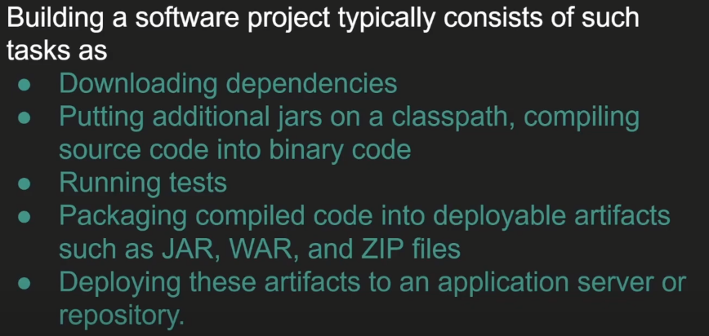

* Maven will do All above points automatically for us.

**What is Spring Framework?**

* It is a Frameworks of Framework.
* It helps developers to work their application rather than worrying about non-functional code.
* In simple way it will help to focus on our Business Logic rather than Worrying about other non-functional requirements.
* It minimizes boilerplate java code.
* **Spring Framework is a Dependency Injection Framework to make Java application Loosely Coupled.**
* Spring Provide IOC (Inversion Of Control) which help Dependency Injection.

**What is Dependency Injection?**

* It is Design Pattern.
* It inject one object into another object.
* Simply means one object dependency will inject in another Object.
* It is used to achieve loose coupling in Java.
* We can achieve Dependency Injection by 2 Ways 🡪 Setter Method and Constructor Method.

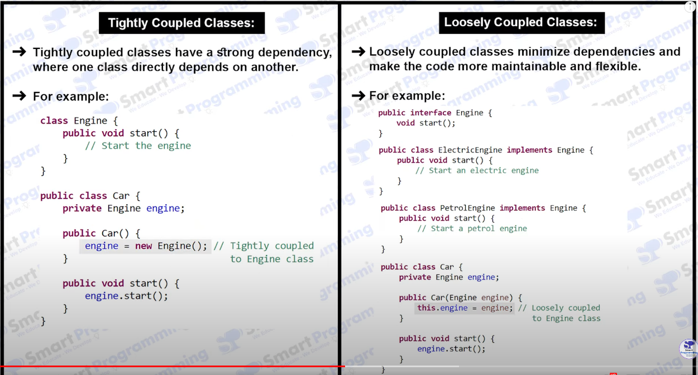

**Inversion Of Control (IOC)**

* Create the Object.
* Hold them in memory.
* And those Object Inject them in Another Object as Require.
* Complete Life cycle of Object creation to destruction is maintained by IOC Container.
* We need provide Beans information and Configuration Information to IOC.

**What is Spring Boot?**